Weapon Master

VR app that combines interactive lessons on Japanese weapons with *game*-style combos, offering an engaging, gamified learning experience.

Team members: Chiriac Andrei, Roman Iulian

Description

1. **Why?**This app provides an accessible and immersive way for users to learn about Japanese weaponry, allowing those without the financial means or physical access to authentic weapons to experience their use firsthand. Additionally, this virtual experience can help users feel more prepared and confident if they choose to pursue martial arts like Kenjutsu/Kendo in a real-world setting.
2. **How?**

Our app will achieve this by blending accurate, historically informed weapon tutorials with an intuitive VR environment, allowing users to practice movements and techniques in a realistic and engaging way. By integrating a combo system, the app creates a challenging but rewarding experience that motivates users to refine their skills while having fun.

1. **What is different** compared to other solutions?  
   Existing applications about medieval fighting primarily emphasize entertainment and often lack detailed guidance on the proper techniques for using these weapons effectively.

Similar products & Relevant Links(>=3)

**Name: Blade & Sorcery**

**Url:** [**Steam**](https://store.steampowered.com/app/629730/Blade_and_Sorcery/)

**Relevant Features**

- Weapon Handling

- World Interaction

**Name: Hell Split: Arena**

**Url:** [**Steam**](https://store.steampowered.com/app/1039880/Hellsplit_Arena/)

**Relevant Features**

- Level Design

**Name: Battle Talent**

**Url:** [**Steam**](https://store.steampowered.com/app/1331510/Battle_Talent/)

**Relevant Features**

- Fluidity

-------------------------------------------------------------------------------------

Main Features

* **PRINCIPAL MAIN VERY IMPORTANT FEATURE: Instructions on how to use Japanese weapons in real-life scenarios.**
* **Other features:**
* **- Historical Context: Learn who and in what context used the weapons**
* **- Skill Assessment**
* **- Combo system (minigame)**

User Journey Diagram - Step by step flow through app

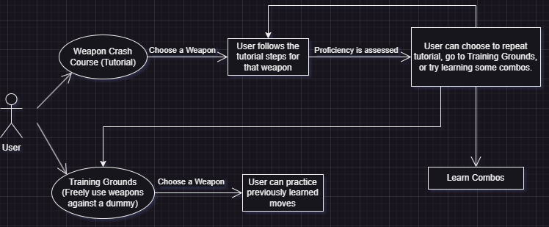

Moodboard (10+ images)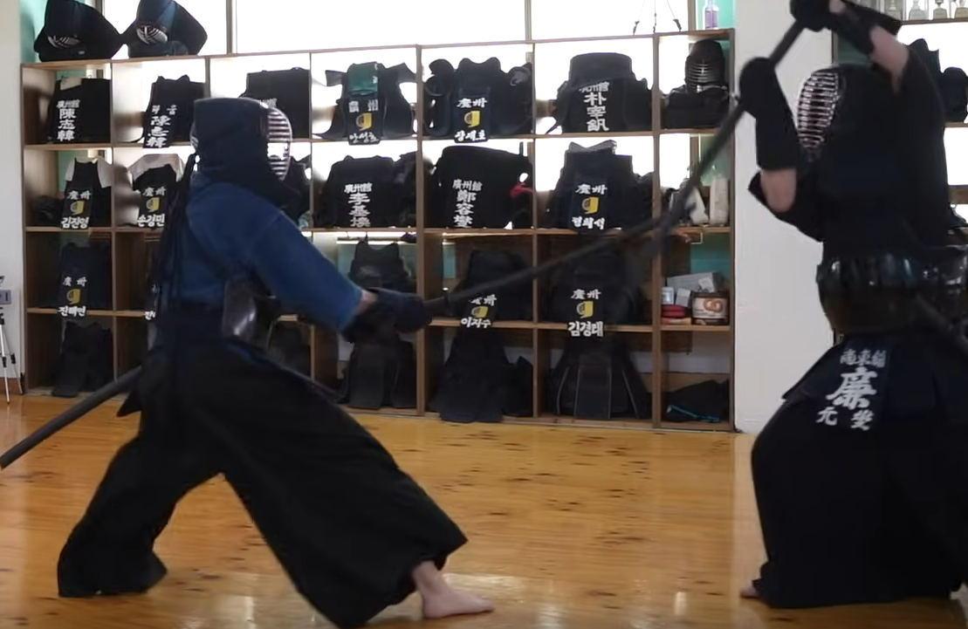

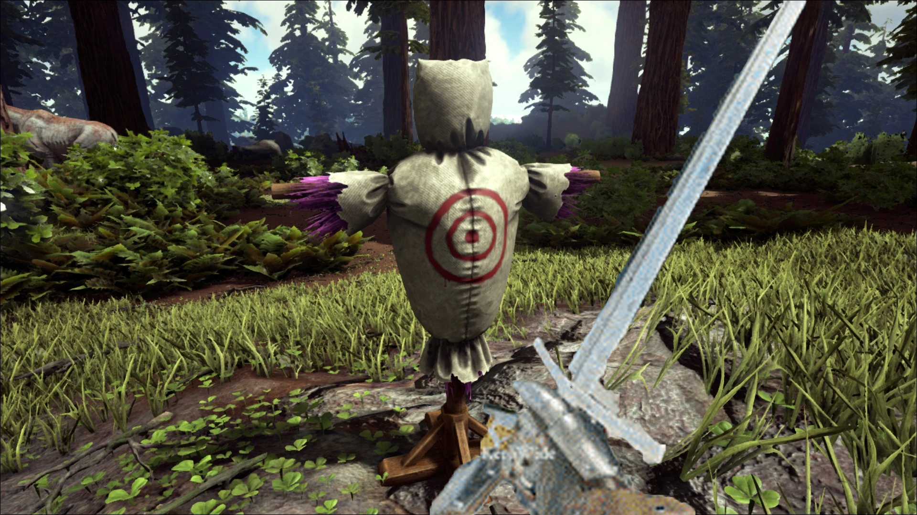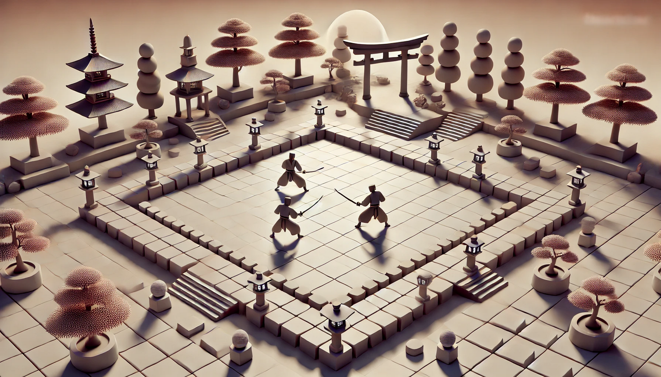

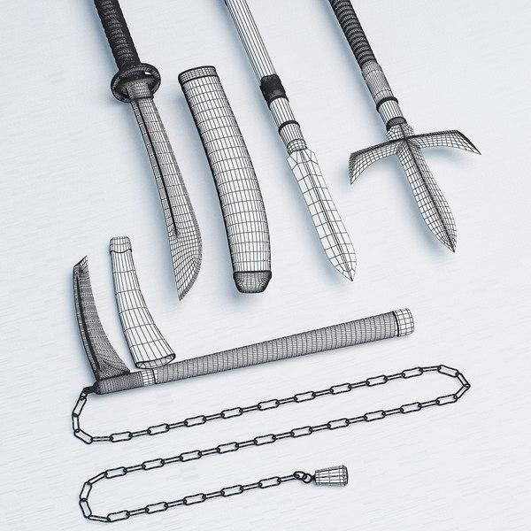

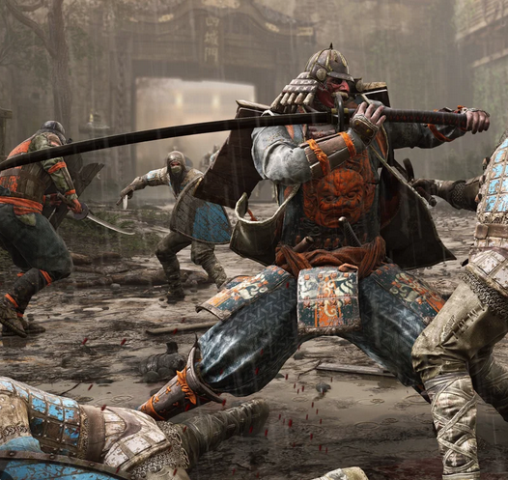

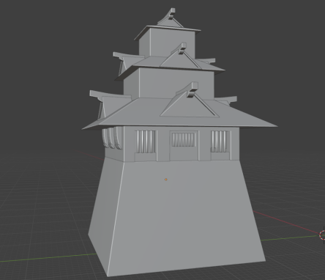





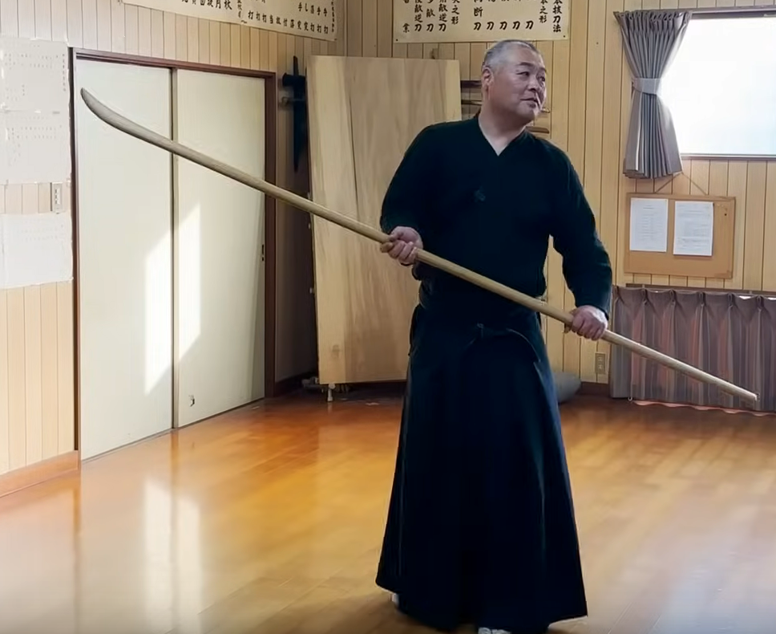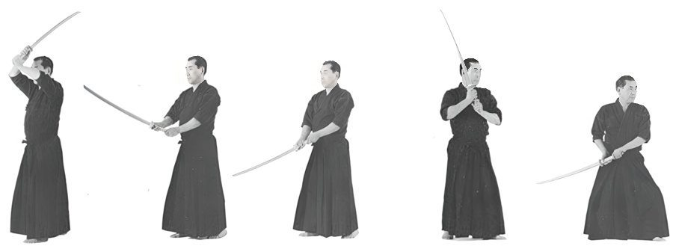

Technologies, Libraries, Assets - Links (>=5)

1. - Unity
2. - XR Interaction Toolkit
3. - Open XR
4. - Free sound for sound FX, [example](https://freesound.org/people/32cheeseman32/sounds/180832/)
5. - Map - Andrei’s A3D project
6. - Kama, Naginata, Katana
7. - [Training dummy](https://assetstore.unity.com/packages/3d/props/lowpoly-training-dummy-202311)